Barracuda vpn client install guide
Client version 5.2

Contents
Installing the VPN Client: 1
Importing VPN profiles 4
Manually creating VPN profiles 4
Connecting to VPN 7
Disconnecting from VPN 8

Installing the VPN Client:
- Download the client from https://www.jolera.com/files/NetworkAccessClient_5.2.0-142_x64.exe
- Run the installer
- Next
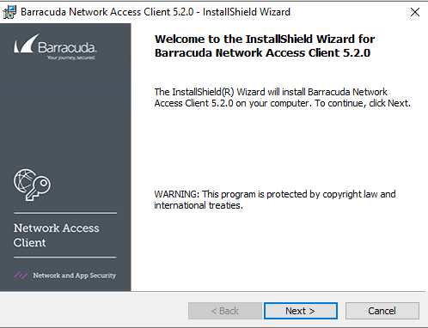
- Accept the license and next
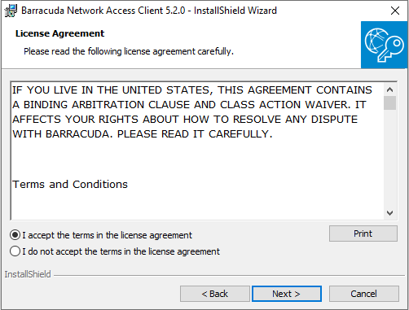
- VPN Client, and next
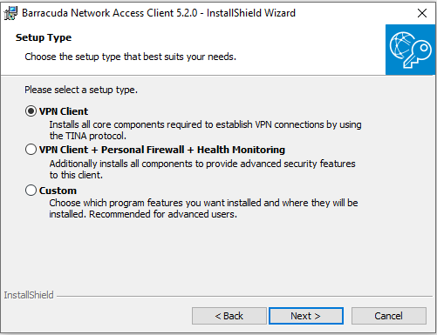
- You can add a master password to prevent unauthorized removal, or leave blank. Next
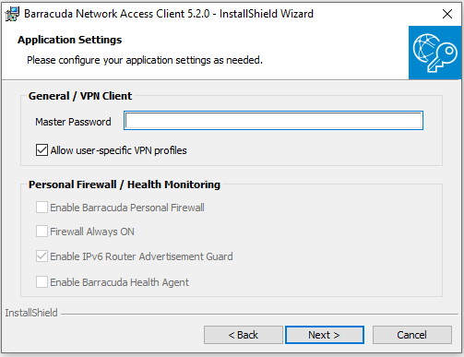
- Install
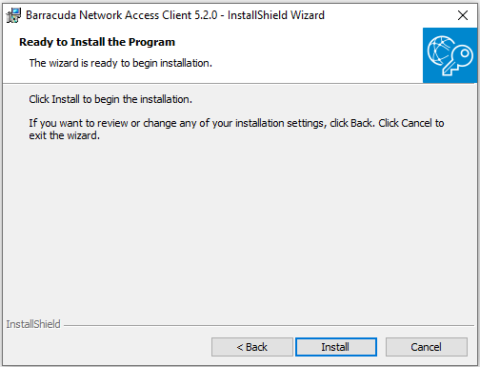
- And finished.
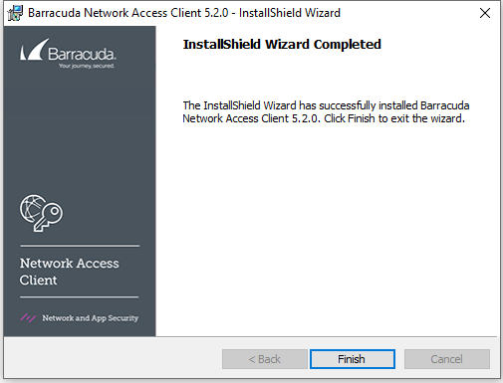

Importing VPN profiles
You can import a VPN profile by double clicking on the .vpn file provided by your IT staff.
After double clicking you’ll get the following message stating the profile was imported successfully.
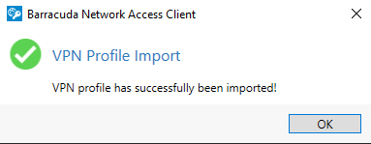

Manually creating VPN profiles
- Find the Barracuda VPN client icon in the system tray
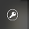
- Right click on it and select VPN
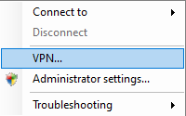
- Click “New Profile” at the top-left
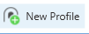
- Select Current User
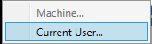
(If you want to create a Machine profile accessible to all users, and available before logon, you can hit the at the top of the screen to authenticate as admin, and you’ll then be able to select “Machine” in this menu.)
- Fill in the VPN info.
The only two required fields are Description and Server address. The rest can be left as default.
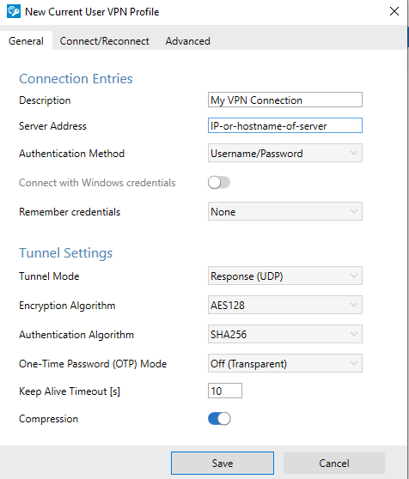
- [OPTIONAL] If you are using MFA you can click the “Connect/Reconnect” tab and adjust the “Connect Timeout” setting to give yourself more time to answer the MFA prompt.
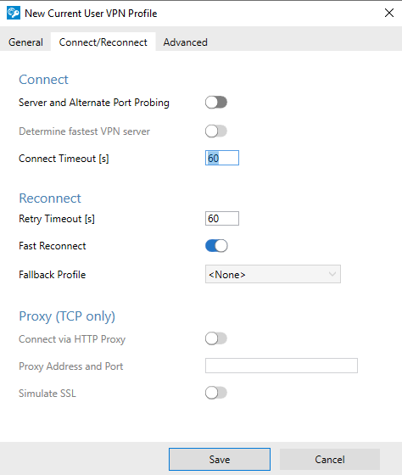
- Click Save
- You should now have the VPN profile set up.

Connecting to VPN
- Find the Barracuda VPN client icon in the system tray
- Right click and select “Connect to >” and then select the desired VPN profile
- Now enter your username and password
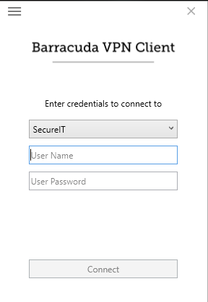
- Hit Connect
- The client will go thru a connection process, and then the system tray icon will turn green.


Disconnecting from VPN
- Find the VPN Client icon in the system tray
- Right click and select “Disconnect”
